**Find Focus – Relative Edge Sharpness**

**What is the program doing?**

1. **Automatically reads in a series of image files**The image series need to be stored in a folder called ***computation,*** within the folder that holds the program.
2. 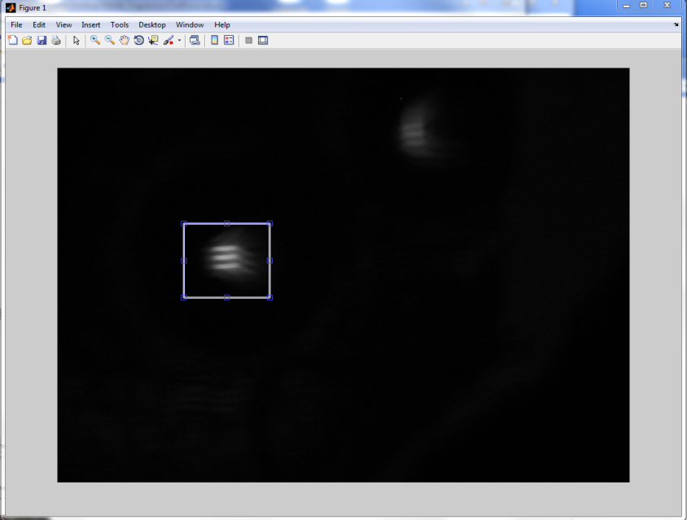**Lets the user select the cropping area that holds the image.**When the program is run, an image is displayed. To select cropping area, click and drag to draw a window around the area containing the image as shown. Double click within the window to accept it. The window can be adjusted using the blue frames prior to the double click. This is done in triplicates.  
     
   **Note**: The window should include some area around the image, but not too much otherwise the results will be influenced by noise in the surrounding area.
3. **Filters the image to remove shot noise.**
4. **Finds a measure of image sharpness for each image within the image series**  
   It differentiates the gray values of all pixels twice in the horizontal, vertical, and both diagonal directions. Then it sums these values and calculates the average for the entire image. This is done for all images in the series.  
     
   Illustration of relative edge sharpness calculations of a “sharp” (top) and “blurry” (bottom) image. Pixel intensity values are at a scale from 0 (black) to 255 (white). The example illustrates that the sum of the second differentiation of the sharp image (600) is higher than the sum of the second differentiation of the blurry image (360).
5. 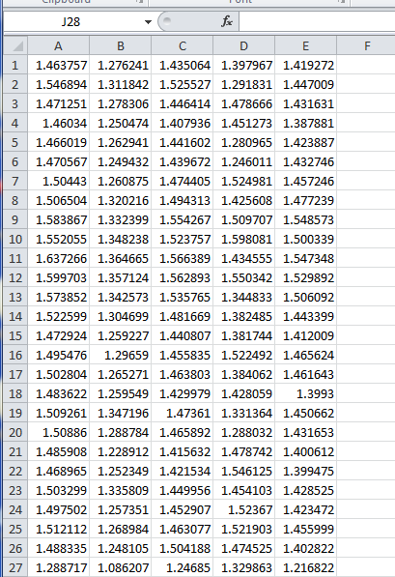**Creates a .csv output file**Example shown here:Each row represents the sharpness measure of one image (row 1 = first image of the image series, row 2 = second image of the image series, etc.).   
   Each column represents one evaluation (column A = first evaluation, column B = second evaluation, etc.)

**Notes**

1. Make sure that input files are being read in the correct order. This is usually a filename issue
2. Set the correct working directory for the filepath and imagestem in find_focus.m
3. If required, adjust the number of ghost (goste) image files to be ignored in find_focus.m  
   **How to run the program and use the Interface?**

Before running the program you need:

* Deposit your image series within the folder called **computation** that is within the folder that holds the program.

To start the program type in **findFocusGui()** in the command window of matlab.

An interface will show up. **Put in all variables** as described below. **There are no error traps**, so if you make a mistake, the program will fail to run. After you put in all variables, click on the **start button** once and follow the instructions given under **What is the program doing?**

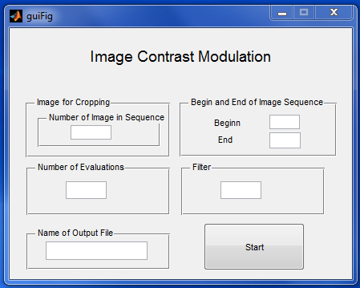

**Image for Cropping:**Determines the image that the program will show you to choose the area that contains the image (see under ***What is the program doing 2.***). Type in the number that indicates an appropriate image (1 for the 1. Image of the series, 2 for the 2. Image of the series, etc.)

**Number of Evaluations**Depending on the image, the output might be influenced by which exact area is chosen for evaluation. For this reason, the series should be evaluated more than only once by choosing slightly different areas. Put in (as a number) how often you want to evaluate the image series.

**Name of Output File:**Indicate how you would like the output file to be names (without file extension).   
Example: If you type in ***test*** the output file will be ***test.xls***

**Begin and End of Image Sequence:**Indicate the ID of the first and last image of the sequence. The program is meant to handle sequences that have image IDs in steps of 5.   
Example: Your image sequence starts with ***510.jpg*** and ends with ***560.jpg***. Type in ***510*** in the Begin box and ***560*** in the End box.

**Filter**  
It determines the filter. Options are 1 and 0.

1 uses filter_24()  
0 uses filter_12()

**What to do if you would like to change the program?**

If you would like to change the Interface, you might want to use the gui construction tool. You can start the tool by typing in **guide()** in the command window of matlab and then follow the prompt.  
  
There are three program files: **do.m**, **find_focus.m**, and **differentiate1.m**. There are also two accessory files**, filter_24.m** and **filter_12.m** which hold the two different filters.

On clicking the start button of the interface the function **do()** within **do.m** is called. The function **do()** then calls the accessory function **filter_24() or filter_12()** in **filter_24.m or filter_12.m** and it calls the function **find_focus()** within **find_focus.m**. The function **find_focus()** calls the function **differentiate1()** in **differentiate1.m**.

The files **findFocusGui.fig** and **findFocusGui.m** are for the interface.